

Canadian Cowboy Challenge Newsletter
July 2026
This is an exciting month as our CCC challenges begin! Please get your entries in as soon as possible for the challenges you want to attend. Unfortunately, our first challenge of the year was cancelled due to low registration, and we want to prevent future cancellations where possible. For the playdays offered the day before each challenge, please check the website for the time the host has offered. Here are the upcoming challenges that we look forward to seeing you at:

July 4-5 Moon Lake Challenge in Entwhistle

July 11-12 YKnott Challenge in Parkland County

August 15-16 Rimbey Ag. Grounds in Rimbey

August 29-30 Eadie Ranch- Rimbey

Sept. 19- Finals- Stettler (invitation only)

We had a board meeting on June 15, and discussed some important information and changes to our finals:
- The Saskatchewan branch will not be hosting challenges or competing in the finals.
- There will not be a buckle for “High Point” or Youth. However, there will still be prizes.
- There will be a riding time available in the Stettler arena from 4:00-8:00.
- The Stettler stalls are $25.00 per night, and there is no self-stalling.
- We are still looking for sponsors, so please reach out to businesses you deal with. Here is the Sponsorship Letter that you can hand out. Shelley has graciously offered the proceeds from one of her play days, which we are grateful for.
- We will be discussing prizes for finals in our next meeting. If you have any suggestions, please share them with us.
The apparel from North Star Sports is really nice and fits well. The next order is due on July 15th. The sizing chart on their website is helpful as the clothing is unisex. Please order HERE.

The Judge’s Certification was completed in May, and two ladies passed the test. Next, they will need to scribe and be a jr. judge to fulfill the requirements. Thank you, Al and Hans, for donating your time! The $425.00 proceeds went back to our club.

Hans will focus on the upcoming challenges in the next edition of the Saddle Up Magazine.

On Behalf of the Board,
~Rolanda

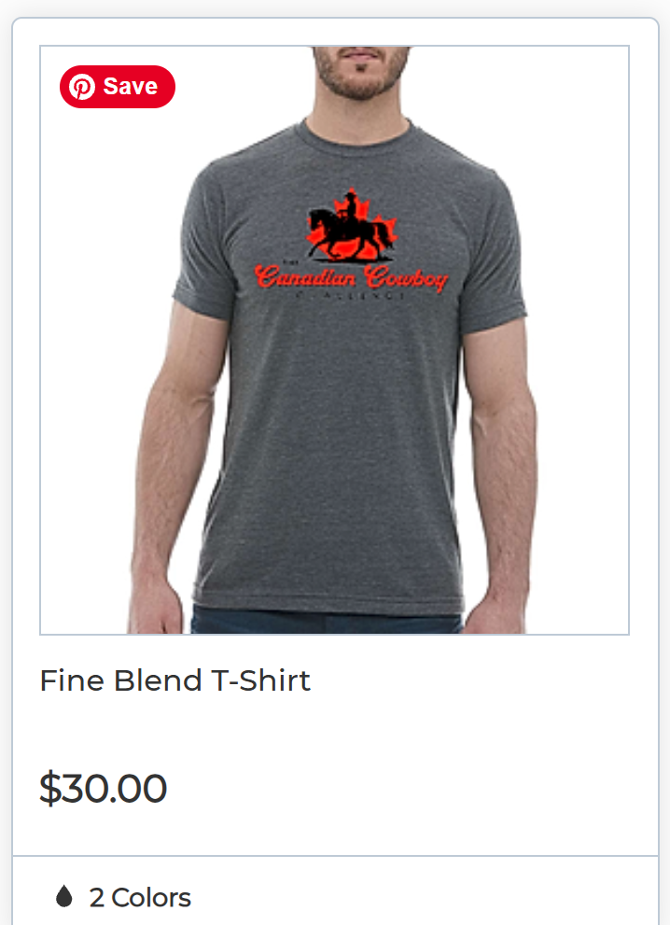
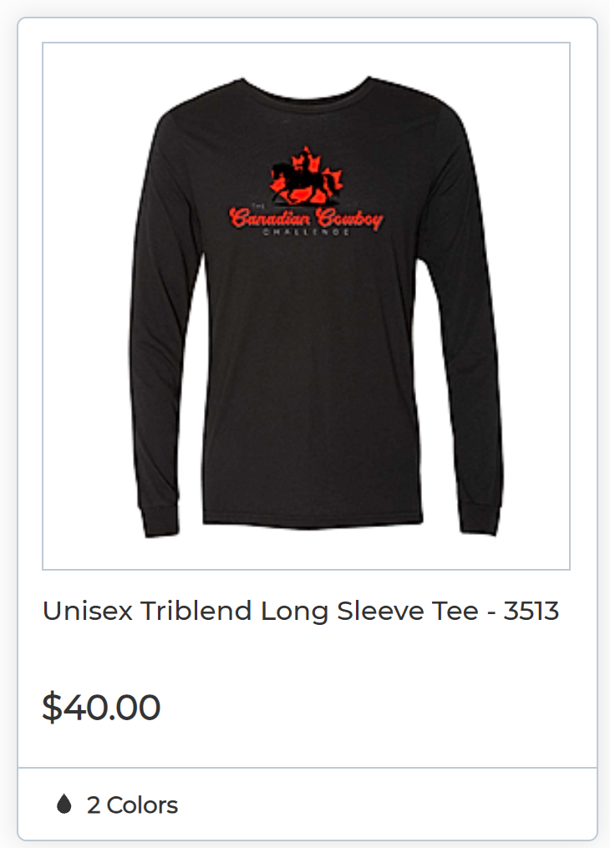
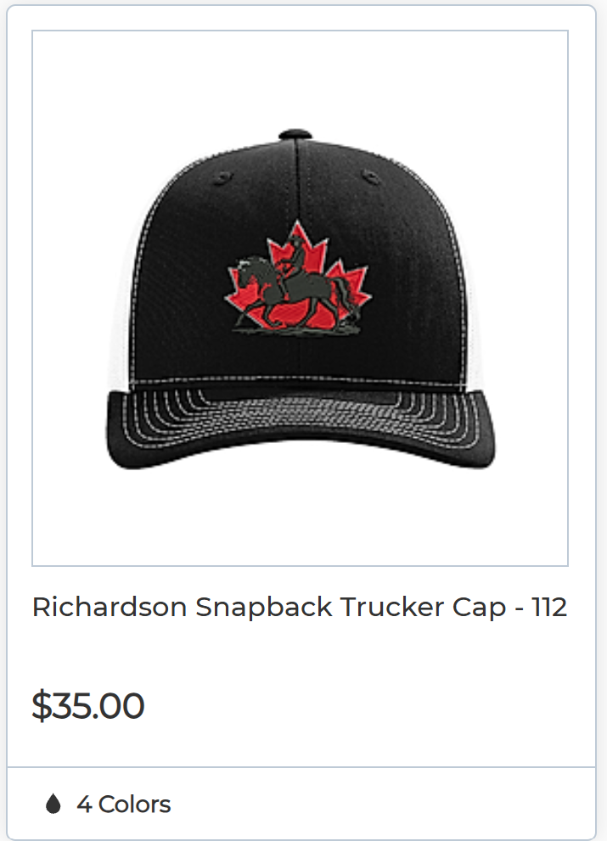
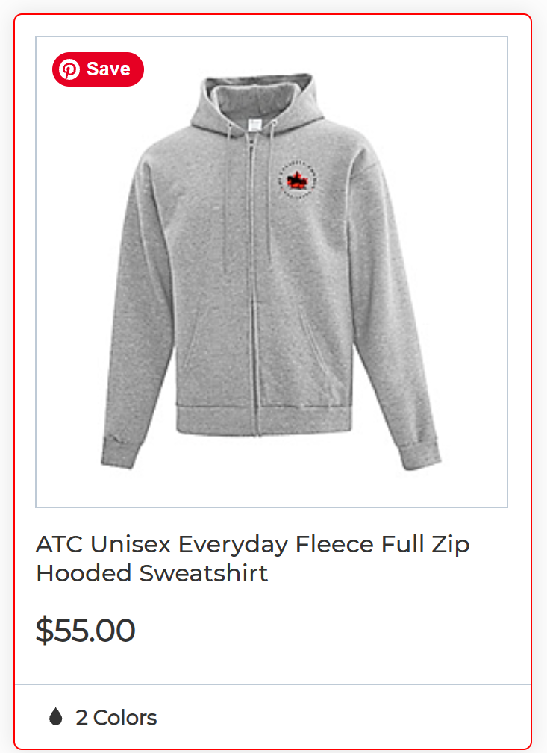
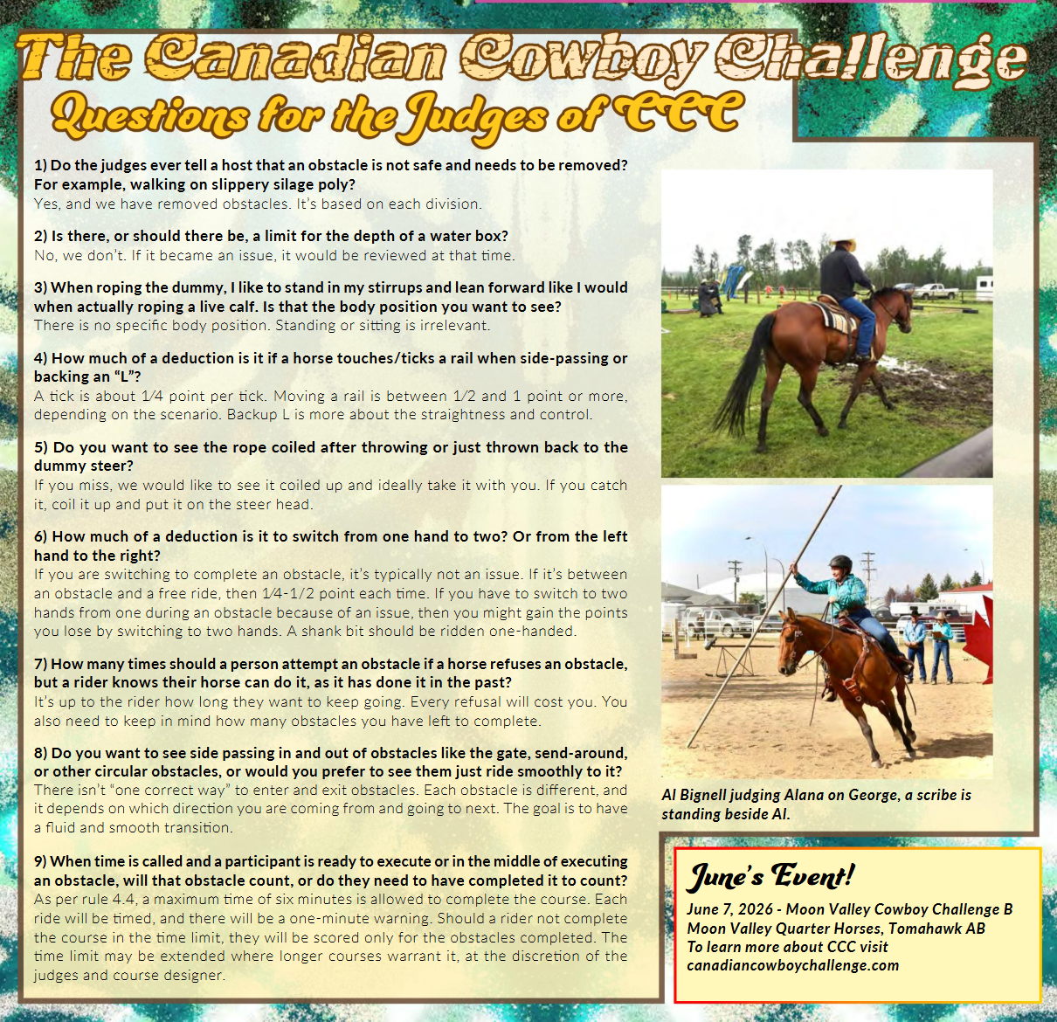
The June Edition of the Saddle Up

